# Use case

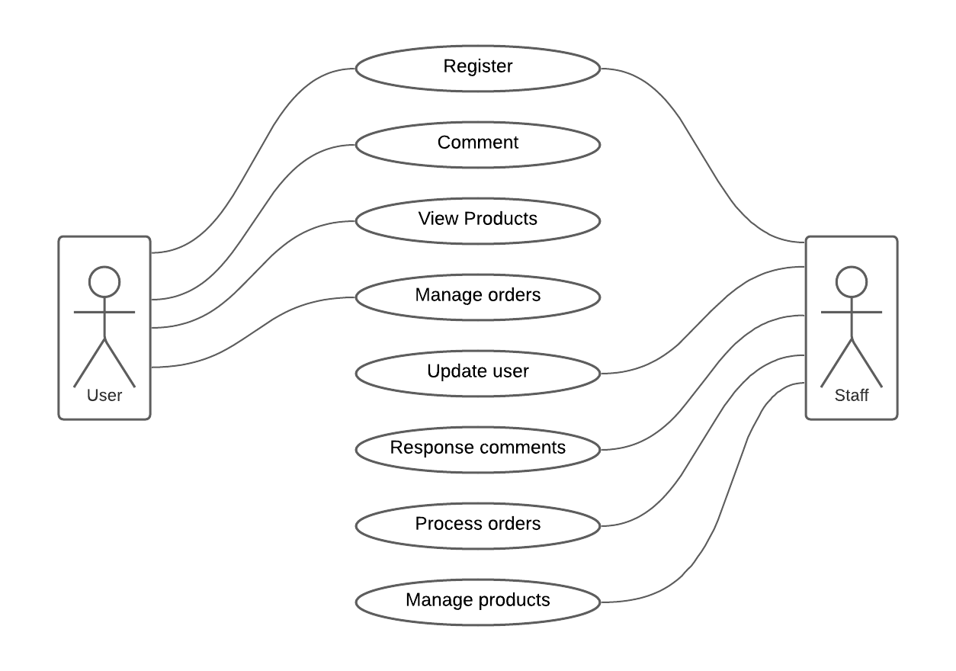

## For users:

* Register: Register to become a member.
* Comment: giving comments and advice about products.
* View products: view products they want based on brands, category, price,...
* Manage orders: Making, canceling, viewing orders.

## For staffs:

* Register: new staff can register
* Update user: update the information of users
* Respond comments: respond to users comments
* Process orders: take, confirm,... users orders
* Manage products: Update information, add, remove products

# ERD

Detailed one: <https://lucid.app/lucidchart/invitations/accept/5b2f341e-0c1d-4620-9411-698c9088db5c>

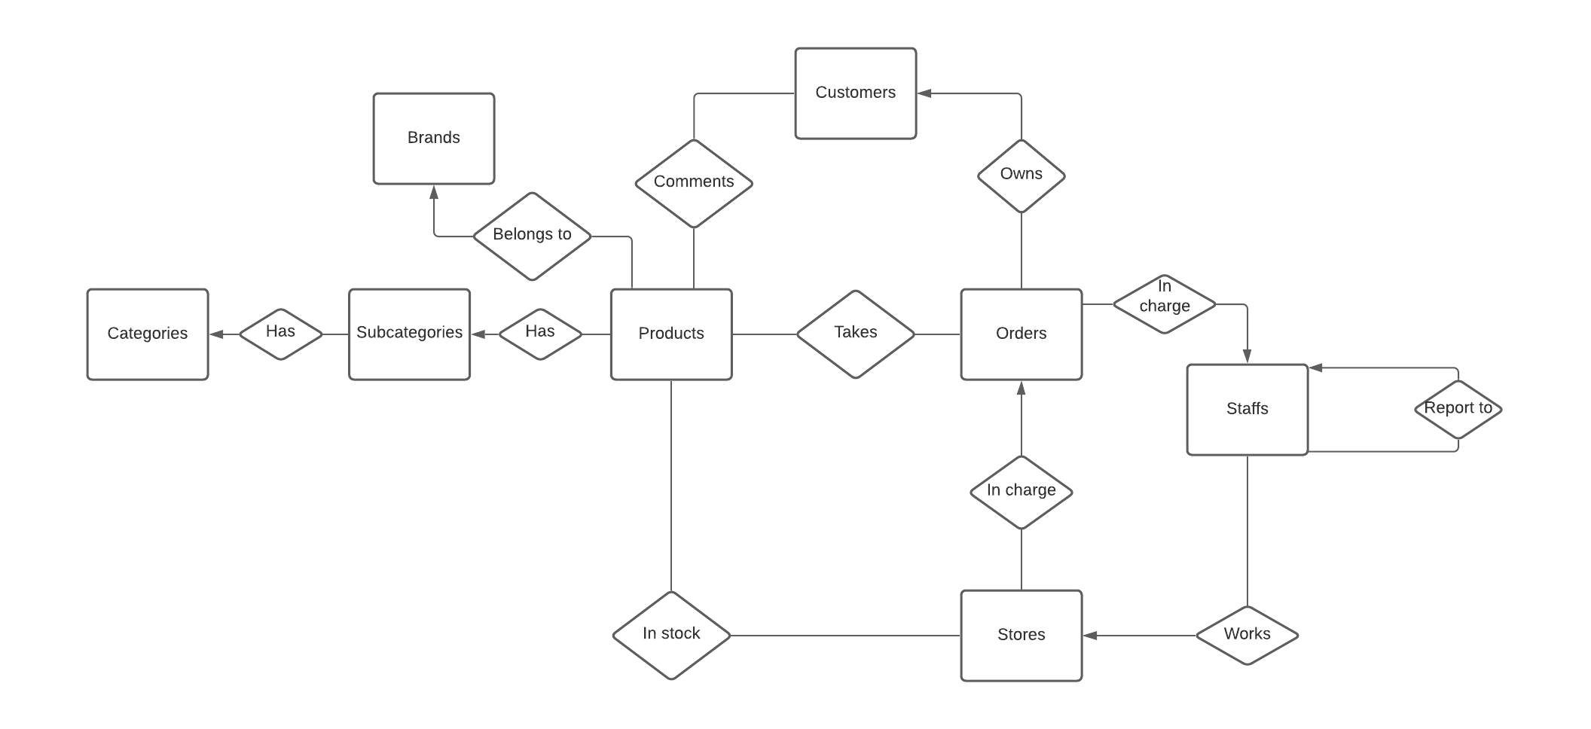

# Proc, Trigger, Transaction.

## Procedure

Main purpose: the Procedure will display all of the products in one order including the Product’s Name, Quantity, TotalPrice for that particular product, and the profit of that product.

The last line depicts the number of Total Quantity, Total Price, Total profit.

## Trigger:

Main purpose: the trigger will check the overall quantity of a given product in stock if it's equal to or greater than the Customer’s quantity of that product.

Description: When inserting into OrderDetails table, automatically set sale price equals to unit price (in Product table) + 100000, and profits of both orders and products will be calculated as (sale price*quantity - unit price*quantity ).

After that tasks, the Total amount will be set as (Old totalAmount + saleprice*quantity of the order that has just added into OrderDetails) and as the same as Profit of Orders (Old Profit + the new one of the order that have just added into OrderDetails)

If the status of an order is ‘Canceled’, totalAmount and Profit will be equal to 0.

## Transaction:

When inserting into the OrderDetails table, this transaction will check the quantity of that product in the Stocks table due to the storeID of that order. If the quantity of that product is not enough to provide that order, the message “Het hang” will be printed out, else, the new product and its quantity will be added into the OrderDetails table.

## [Full script of Assignment.](https://drive.google.com/drive/folders/163STbkarthwhf0OJZu4KCncrWpTZHaWc?usp=sharing) Note: Please run the trigger before run the gendata.sql